**HR ANALYTICS PROJECT 4**

**Project description:**

Hiring process is the fundamental and the most important function of a company. Here, the MNCs get to know about the major underlying trends about the hiring process. Trends such as- number of rejections, number of interviews, types of jobs, vacancies etc. are important for a company to analyze.

**Approach:**

As a data analyst we need to extract insights from data given related to business, organization, company. 1st we need to extract the data, clean the data and then processed the data using SQL, excel and at last making meaningful dashboards. While cleaning the data I have removed outliers, duplicate columns.

**Project software:**

I have used excel 365 , for exploratory data analysis.

**Insights:**

I have extract the data in excel form, removed the duplicate values. Then I removed outliers. Adjust the data to understand it easily. Added one month column to show applications in different months.

Then I did conditional formatting. And created different meaningful graphs to know data neatly. I have used some formulas to create new columns, pivot tables to merge and compare columns. 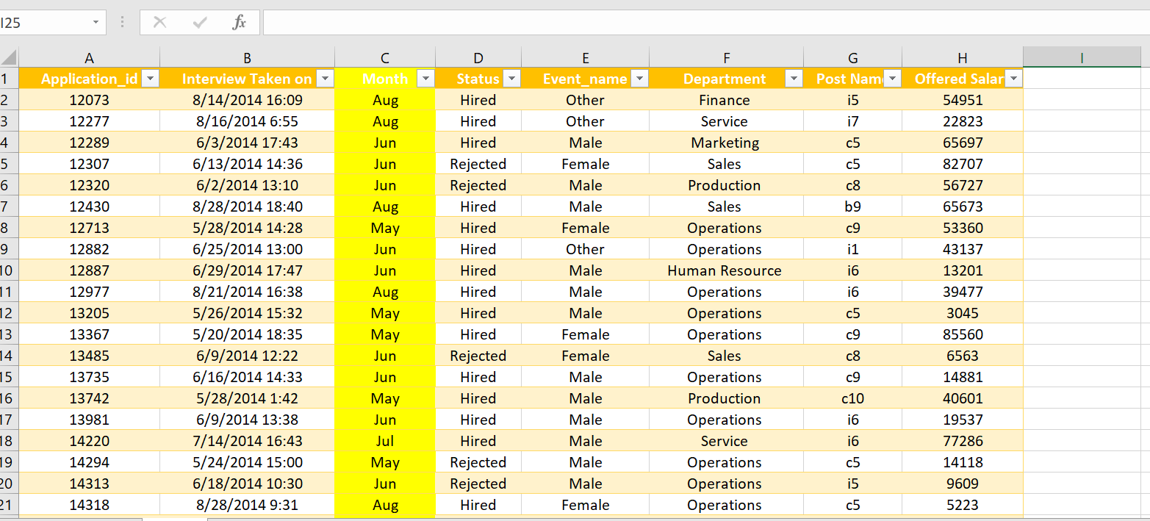

1. Male and female hired by company: 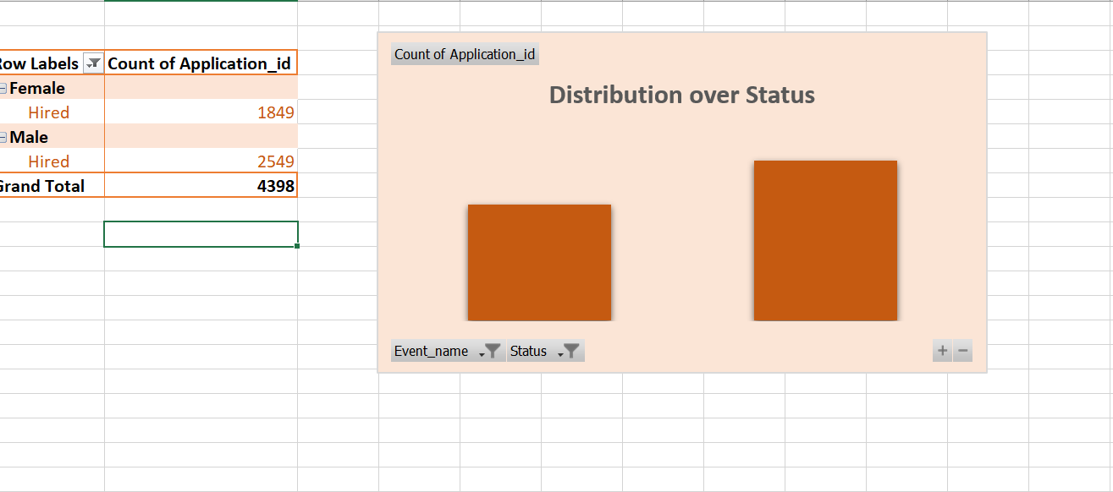
2. Average salary offered in this company

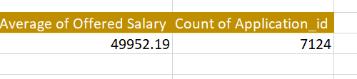

1. Class intervals for this salary:

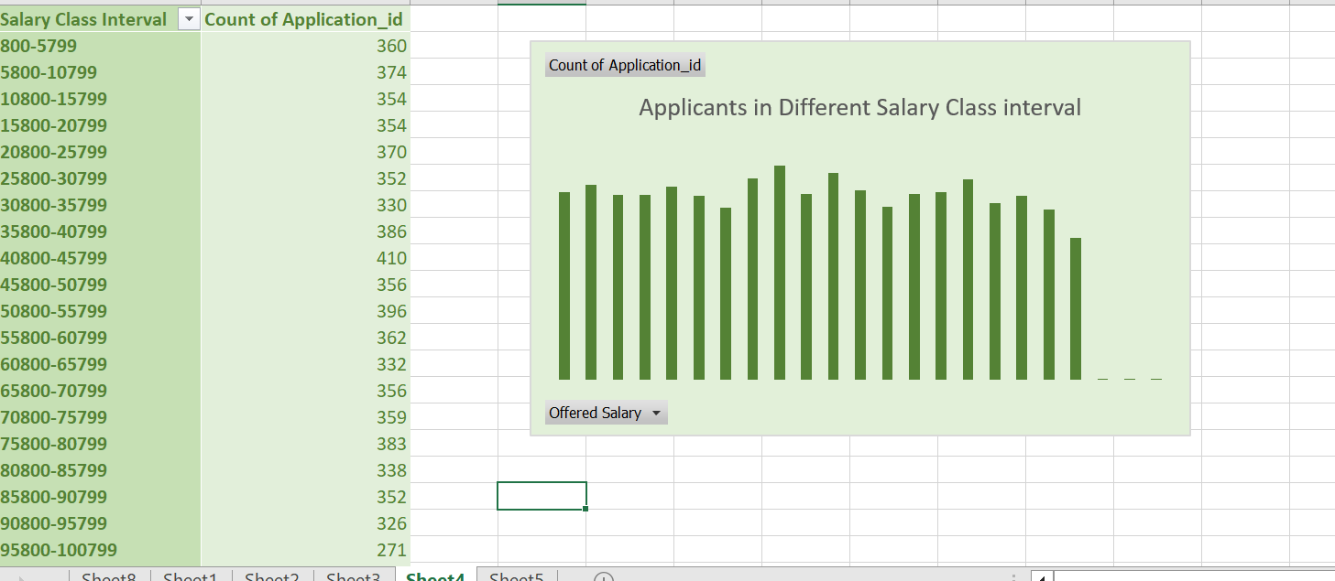

1. Proportion of people working in different department:

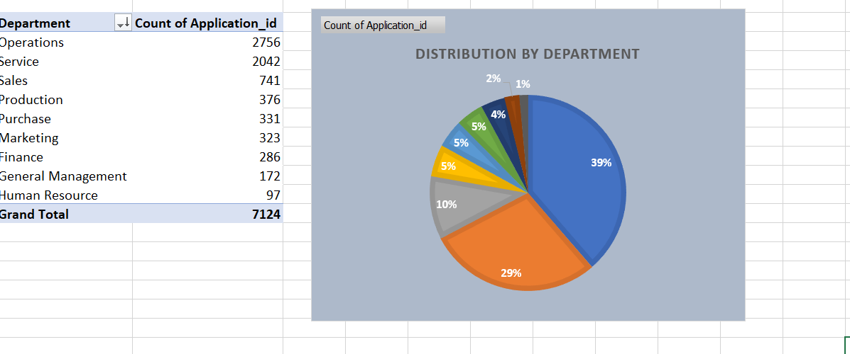

1. Different post tiers using graphs:

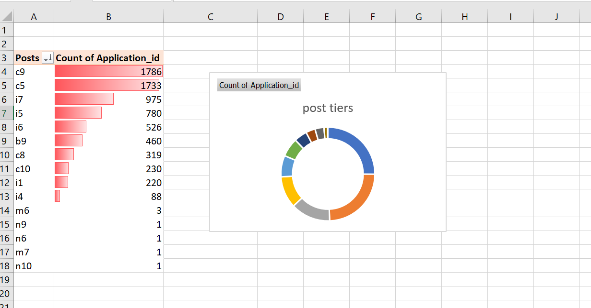

**Result:**

There were total more than 7.5K rows of data , after removing duplicates we get 7125 rows.

C9 post is having maximum applicants.

Operations department is having maximum applications.

Average salary is 49.9K .